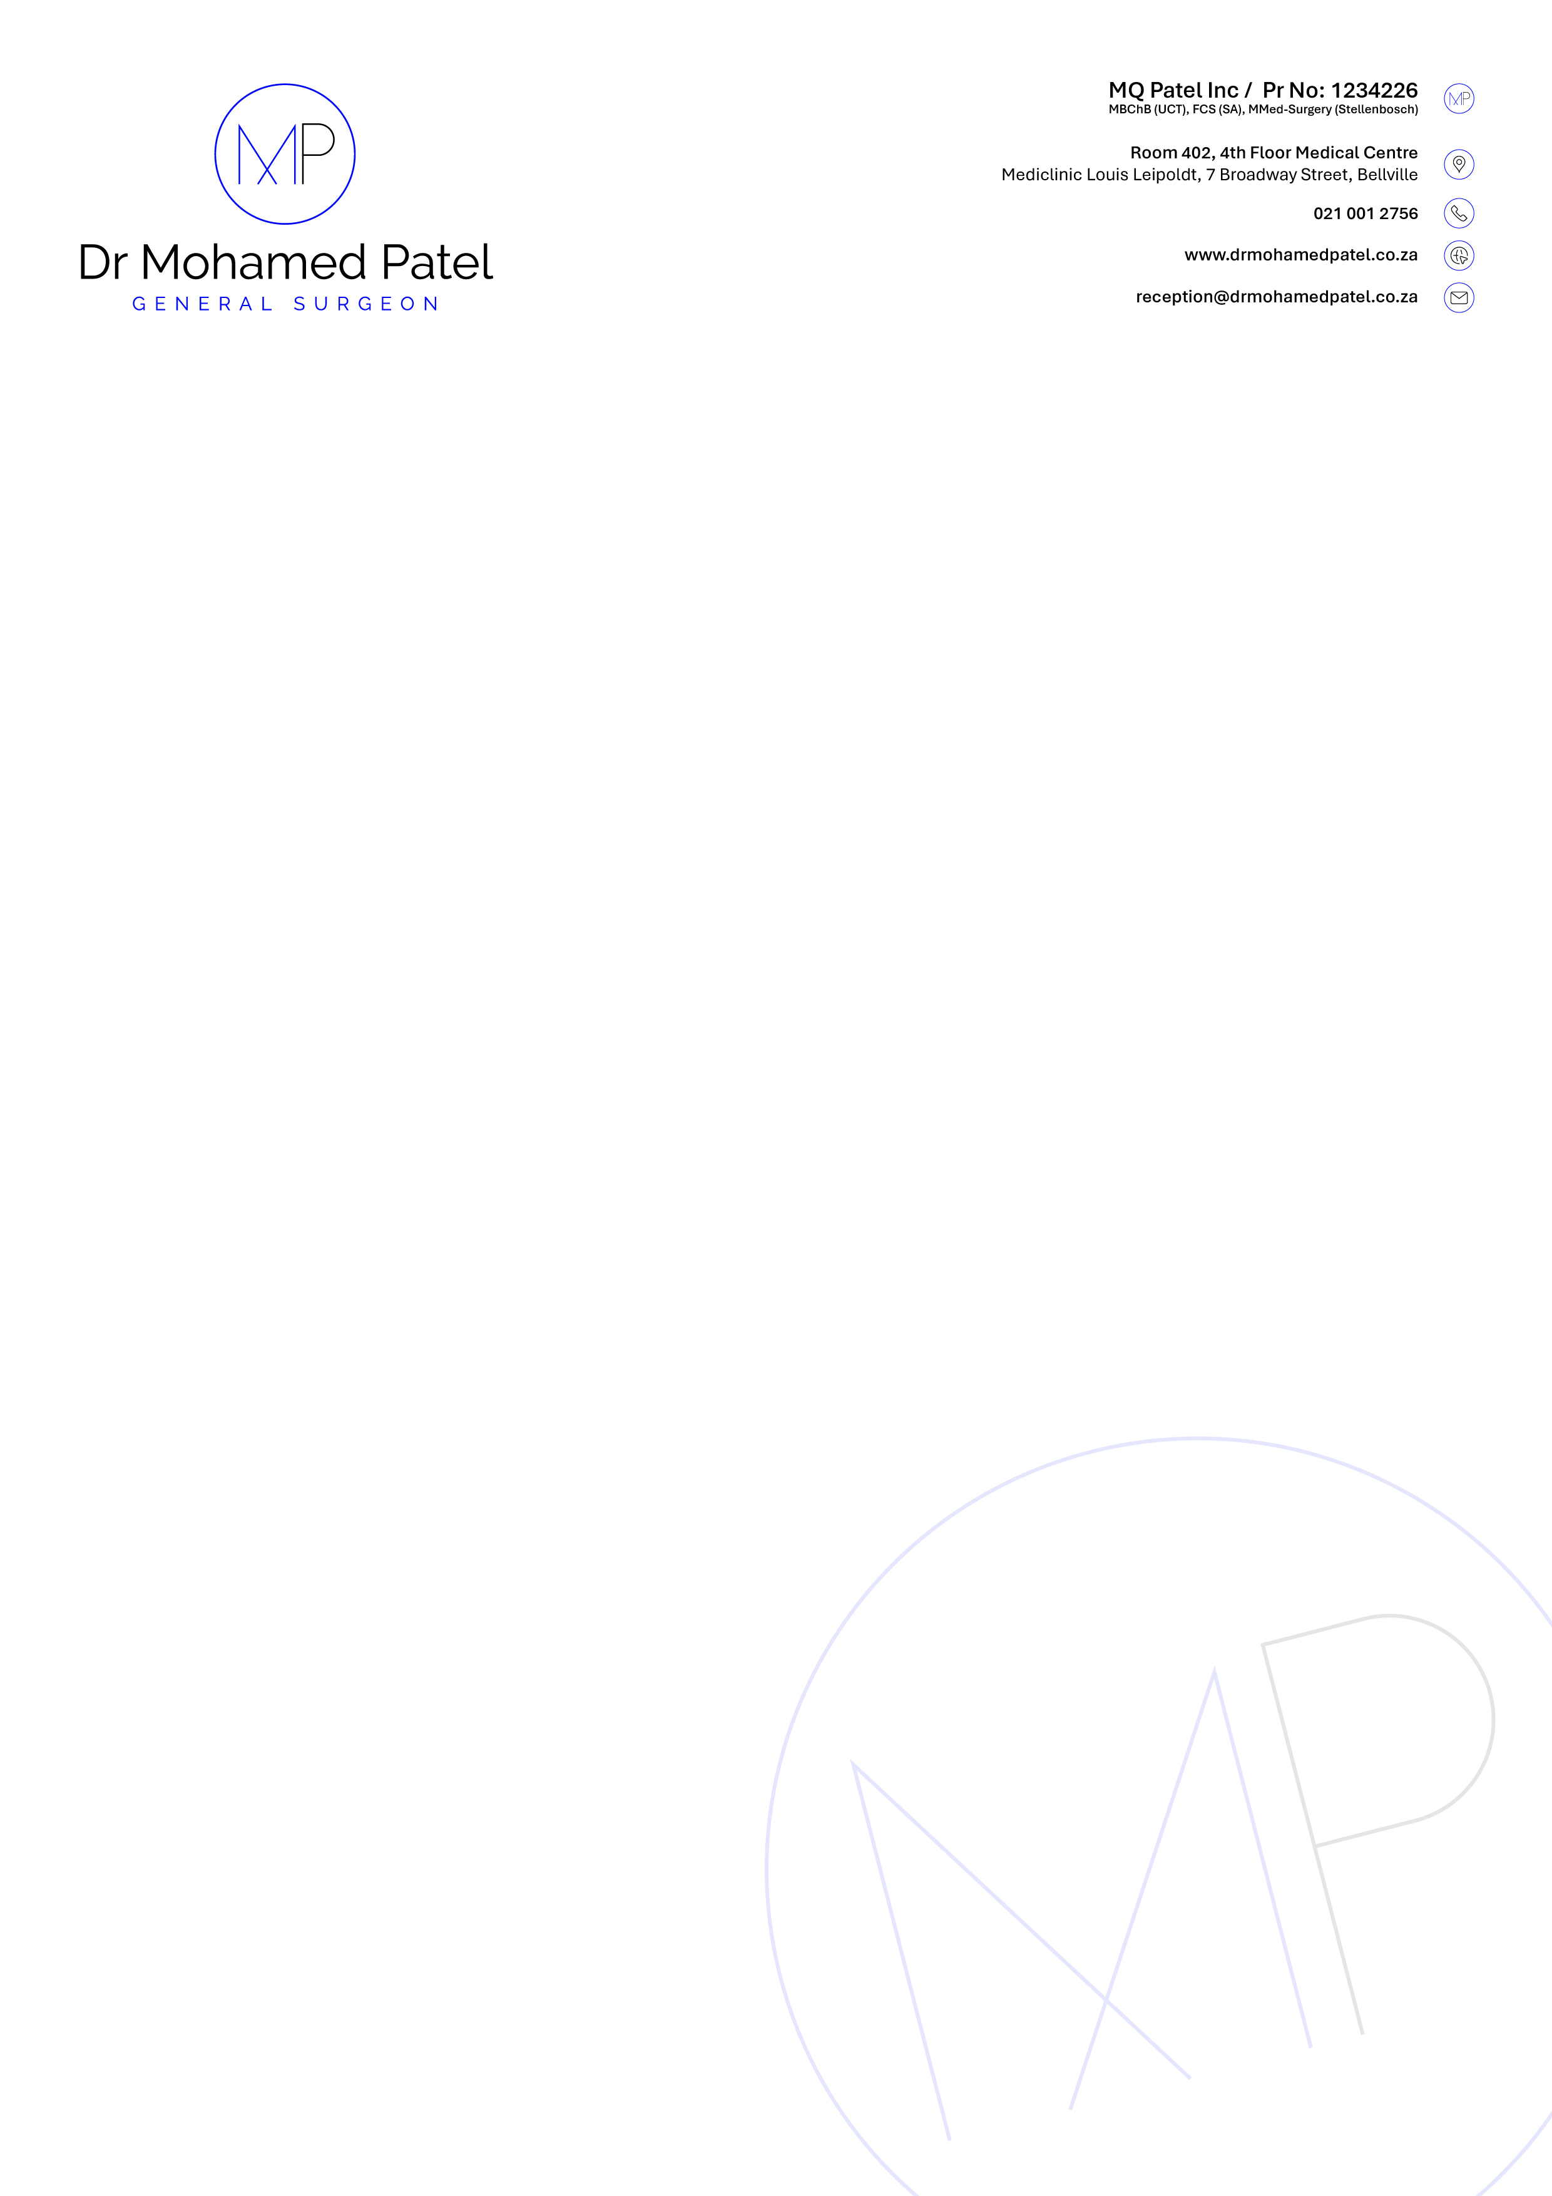
PRESCRIPTION

Patient Surname, Name: {{ patient_name }} | Date of Birth: {{ dob }}
Medical Aid: {{ medical_aid }} | Date: {{ current_date }}

ICD 10
{{ icds }}

{{ prescription }}

Dr Mohamed Patel

